Microservices Architecture using ASP. NET Core WebAPI
1. Microservices - JWT :
Question 1: Implement JWT Authentication in ASP. NET Core Web API :
Scenario:
You are building a microservice that requires secure login. You need to implement JWT based authentication.
Steps:
1. Create a new ASP.NET Core Web API project.
2. Add a `User` model and a login endpoint.
3. Generate a JWT token upon successful login.
4. Secure an endpoint using `[Authorize]`.

Code :
Appsettings.json :
{
"Jwt": {
"Key": "ThisIsASecretKeyForJwtToken",
"Issuer": "MyAuthServer",
"Audience": "MyApiUsers",
"DurationInMinutes": 60
}
}

Program.cs :
using Microsoft.AspNetCore.Authentication.JwtBearer;
using Microsoft.IdentityModel.Tokens;
using System.Text;
var builder = WebApplication.CreateBuilder(args);
var jwtKey = builder.Configuration["Jwt:Key"]
?? throw new InvalidOperationException("JWT Key is missing in configuration");
var jwtIssuer = builder.Configuration["Jwt:Issuer"];
var jwtAudience = builder.Configuration["Jwt:Audience"];
builder.Services.AddAuthentication(options =>
{
options.DefaultAuthenticateScheme = JwtBearerDefaults.AuthenticationScheme;
options.DefaultChallengeScheme = JwtBearerDefaults.AuthenticationScheme;
})
.AddJwtBearer(options =>
{
options.TokenValidationParameters = new TokenValidationParameters
{
ValidateIssuer = true,
ValidateAudience = true,
ValidateLifetime = true,
ValidateIssuerSigningKey = true,
ValidIssuer = jwtIssuer,
ValidAudience = jwtAudience,
IssuerSigningKey = new SymmetricSecurityKey(Encoding.UTF8.GetBytes(jwtKey))
};
});
builder.Services.AddAuthorization();
builder.Services.AddControllers();
var app = builder.Build();
app.UseHttpsRedirection();
app.UseAuthentication();
app.UseAuthorization();
app.MapControllers();
app.Run();

LoginModel.cs :
namespace JwtAuthDemo.Models
{
public class LoginModel
{
public string? Username { get; set; }
public string? Password { get; set; }
}
}

AuthController.cs :
using JwtAuthDemo.Models;
using Microsoft.AspNetCore.Mvc;
using Microsoft.IdentityModel.Tokens;
using System.IdentityModel.Tokens.Jwt;
using System.Security.Claims;
using System.Text;
namespace JwtAuthDemo.Controllers
{
[ApiController]
[Route("api/[controller]")]
public class AuthController : ControllerBase
{
private readonly IConfiguration _config;
public AuthController(IConfiguration config)
{
_config = config;
}
[HttpPost("login")]
public IActionResult Login([FromBody] LoginModel model)
{
if (IsValidUser(model))
{
var token = GenerateJwtToken(model.Username!);
return Ok(new { Token = token });
}
return Unauthorized("Invalid credentials.");
}
private bool IsValidUser(LoginModel model)
{
return model is not null &&
!string.IsNullOrWhiteSpace(model.Username) &&
model.Username == model.Password;
}
private string GenerateJwtToken(string username)
{
var claims = new[]
{
new Claim(ClaimTypes.Name, username)
};
var key = new SymmetricSecurityKey(
Encoding.UTF8.GetBytes(_config["Jwt:Key"]!));
var creds = new SigningCredentials(key, SecurityAlgorithms.HmacSha256);
var token = new JwtSecurityToken(
issuer: _config["Jwt:Issuer"],
audience: _config["Jwt:Audience"],
claims: claims,
expires: DateTime.Now.AddMinutes(60),
signingCredentials: creds
);
return new JwtSecurityTokenHandler().WriteToken(token);
}
}
}

SecureDataController.cs :
using Microsoft.AspNetCore.Authorization;
using Microsoft.AspNetCore.Mvc;
namespace JwtAuthDemo.Controllers
{
[Authorize]
[ApiController]
[Route("api/[controller]")]
public class SecureDataController : ControllerBase
{
[HttpGet("secret")]
public IActionResult GetSecret()
{
return Ok("This is protected data only visible to authenticated users.");
}
}
}

OUTPUT :
POST : https://localhost:7092/api/auth/login :
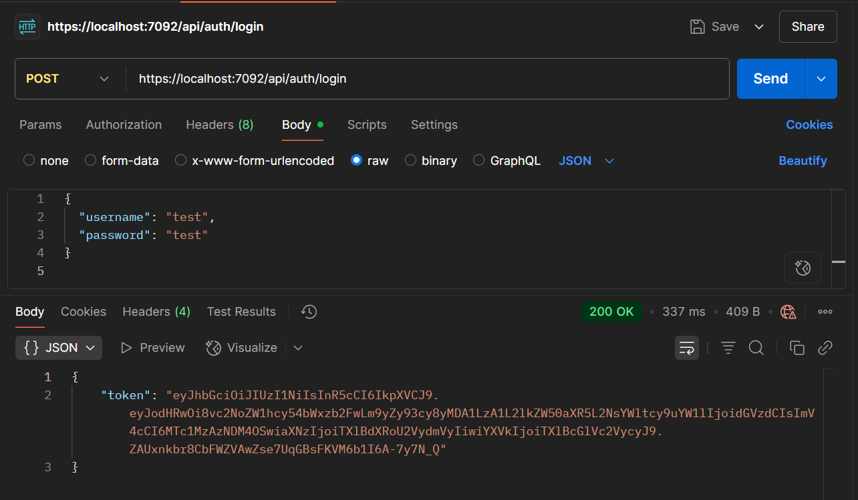

GET : https://localhost:7092/api/securedata/secret :
